Draw some birds and animals from Brazil, can you have a go at writing their names?  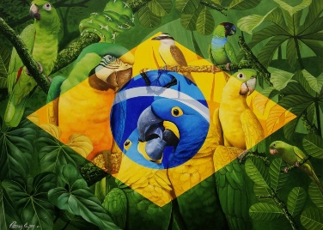 | Practise writing your numbers up to 20. | Make up a carnival dance to show your friends and/ or family.  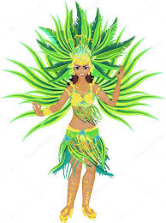
Create your own carnival outfit using old clothes, unwanted fabrics and other fabulous decorations such as feathers or sequences. | An idea of your own! | Watch the film “Rio!” and retell the story to your family and/ or friends. Can you have a go at making a mini-book about the film?
Find some Brazilian recipes online and try and make them with your family. | Design and create your own carnival float- perhaps on a shoe box. What characters, animals and decorations would you choose? | Find out about some famous Brazilian sports stars.

