Rainbows Home Learning Autumn Term 2 Theme: The Gingerbread Man and Celebrations

Do some yummy gingerbread baking.

What shapes can you make?



Share your favourite nursery rhyme with a grown up.

Ask your grown up what their favourite nursery rhyme is.

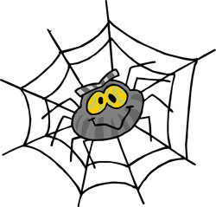

Go on a listening walk. How many sounds can you hear?



Count to 10. How many red, blue, yellow, pink, purple, brown and black things can you count in your home?

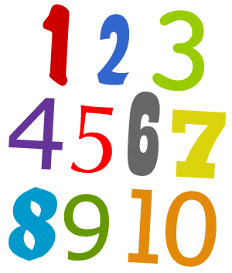

Help write any Christmas cards, letters etc. In December bring some letters to post in our role play Post Office.



**If you do any home learning please put it on tapestry we would love to see it**



Act out the story of ‘The Gingerbread Man’ with your family. Which character is your favourite?

Make/draw a firework picture. How many colours have you used? Perhaps you could put a picture of you celebrating it on Tapestry…..



Practice putting on your coat/hat/scarf/gloves. Also, try putting on your forest school all in one.

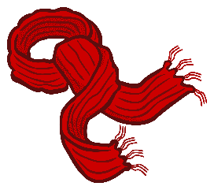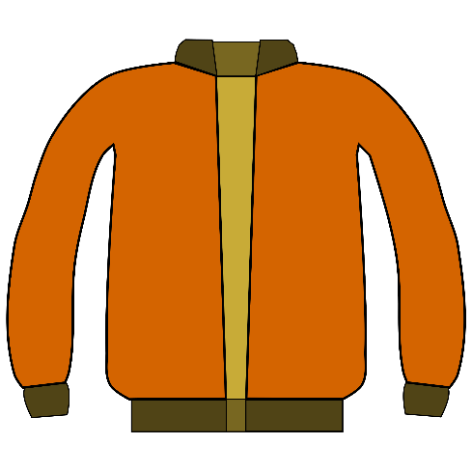

Look for some road signs. What shape are the road signs? Are there any numbers on them?

