Reception Home Learning Term 2 – ‘The Gingerbread Man’
Use our class story-map to tell your family the story of ‘The Gingerbread Man’. | Create a story map of one of your favourite stories. Bring it in to school to share with your class.  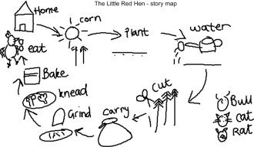 | Go on a number hunt – indoors and outdoors. You can take photographs, draw pictures or write about what you find. What is the highest number you can find?  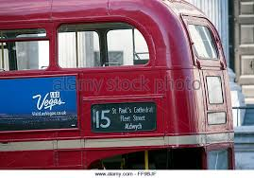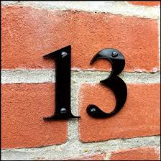
Practise doing your zip / buttons on your coat. | Use the attached letter/sound cards to have a go at making some simple words.  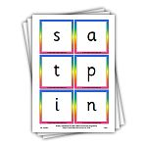 | Go for a nature walk with your family. Collect any items of interest to show the class. Maybe you could count how many different animals you spot?
Try a new fruit or vegetable that you have never tried before. | In the story, the Gingerbread Man went on a journey. Can you draw a map to show your way home from school?  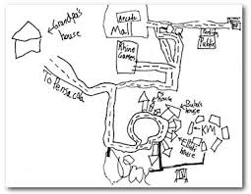 | An idea of your own…

Be as creative as you like and enjoy the home learning activities. We would LOVE to see more photographs and notes on Tapestry about any home learning – either using the ideas on this page or any other ‘wow’ moment!

