Topic: Fallen Fields Novel: private peaceful Story: Christmas Football
Please choose a number of pieces of home learning to complete over the next few weeks. Everyone is expected to complete at least 30 points of homework. Certificates will be presented to anyone who complete 100 points or more of home learning.
 | 5 points | 10 points | 15 points | 20 points
English | Write a fictional diary as a child during World War 1.  Remember to add detail.  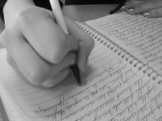 | Design a recruitment poster  to persuade people to fight for their country during the War. | Write a poem inspired by WW1. It could be emotive, a recruitment poem or your own version of a well-known war poem. | Write a non-chronological report about World War 1.
Maths | Create a poster showing other people how to simplify fractions or find equivalent fractions  ½  ¾  ¼ | Write 5 word problems that involve fractions. | Create a poster showing other people how to multiply fractions.  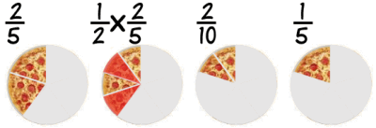 | Create a maths game where you have to apply your knowledge of fractions. 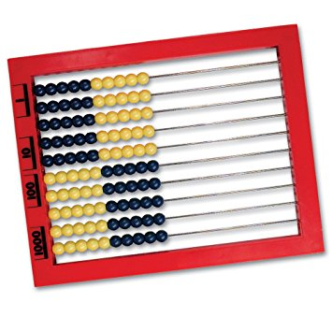
Other | Research the Christmas Truce.  Present your information in an interesting way.  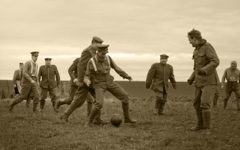 | Using different materials, create a drawing, painting or collage that portrays a scene from World War 1. | Make your own artefact  from World War 1 – this could be a rationing book, an evacuation case, a gas mask, soldier’s helmet or a medal. | Create a fact-file  about the life of a child during World War .1  