Can you prepare a healthy meal, fit for a superhero? | Complete a shape hunt in your house. What shapes can you find? Draw pictures or take photos to show your class. | Design your own villain, think about how they might look and what their personality might be like.  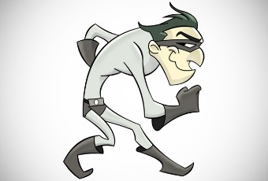
Make a picture book or comic book detailing the adventures of a superhero. What could they get up to? How do they save the day? | An idea of your own!  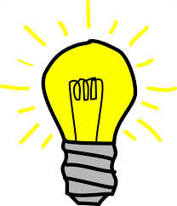 | Using old fabrics and other materials, can you make your own superhero costume? Think about what materials would be useful. What is your superhero name and what are your powers?
Design and make your own superhero gadget. How can it help good conquer evil?  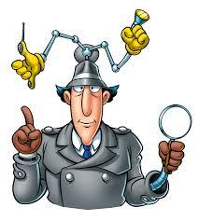 | Read a superhero story with a grown up. Can you come up with a different ending? | Use information books and the web to find out about Guinness World Record holders and their superhuman achievements.

