Year 5 Home-Learning Menu Autumn 2 Time Travelers 10 points for each piece submitted. Target is 40points by the end of the term. Reward given for children who reach the target.
Art/D.T | Maths | Geography | History | Science | English/Writing
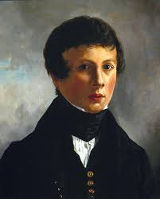  Sketch a portrait of either yourself or of another person. | Collect data from your daily life and present it in a form of data handling (bar chart, line graph, pie chart etc). For example: how long you spend daily on the x-box, sleep patterns. | Interview/speak to someone who has lived in Didcot for some time. Ask them to tell you about the changes that have happened. | 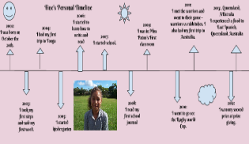  Create a timeline of your life with significant events and pictures. | 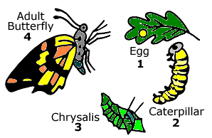  Present a project on life-cycles. | Interview an older/retired person and record written conversation.
Use recycled materials to create an art piece that showcases a change in history. | Work out the area and perimeter of your home.  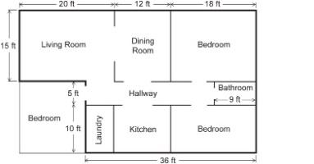 | Design your own town and draw a map of it. You must include a key. | Research how transport has evolved over the past 200 years and present findings. | Classify different animal types.  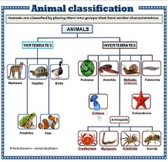 | Write a diary entry in role as a child living in 2100.
Create an art piece that is in the style of a famous artist. | Design and make a maths game to play with your peers to teach them about the inverse. | Research how Didcot has changed over the last century. | Research how gender roles have developed over the last century. | Conduct and evidence a science experiment. | Write a newspaper report on an event.
Design a house that you might see in 2100. | Design and make a maths game to play with KS1 children to teach them about addition. | Take a picture in Didcot of the oldest house you can find and then take another of a new house. | Compare toys from the past t modern day ones. How have they changed? Find images of past toys. | Record the temperatures for a week/month and record findings.  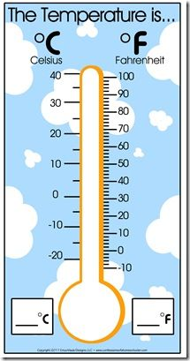 | Write a narrative of your choice which includes some form of time traveling.

 | Week 1 | Week 2 | Week 3 | Week 4 | Week 5 | Week 6
Pattern | Word endings with: ‘ant’ and  ‘ent’ | Word  Endings with:  ‘ance’, ‘ancy’  and ‘ence’ and ‘ency’ | Word  endings with: ‘able’, ‘ible’ and ‘ably’ and ‘ibly’ | Suffixes & cc,  Xc and cqu | ei and ie words | Words with  ‘ough’
Words | Accident  Arrogant  Elephant  Convenient  Restaurant | Transparency  Frequency  Hesitancy  Expectant  Transparent | Adorable  Possible  Horribly  Considerably  applicable | except  excite  exclaim  acquire  acquaintance | Shield  Receive  Receipt  Deceive  Ceiling | Cough  Trough  Through  Although  Plough
Spelling is important!
Spelling rules to be taught this half term. Your child will be taught the rule for each pattern each week and then will be tested on 10words involving that rule on a Friday. Five of the ten words that will be tested are below and then the other five, will be words applying the rule/pattern.

