***Links with Parents***

TBC – a series of school readiness workshops

11th May & 18th May Father day forest school

***Expressive Arts and Design***

The children will learn printing techniques as they print with vegetables and have a go at collography making their own printing template.

Child initiated play in the home corner and small world area will see children working together to make up stories. This will link in with children narrating and acting out ‘helicopter stories’.

Children will be exploring music and movement to different kinds of music.

Outside we will be playing a range of ring games such as ‘Farmers in the Den’.

***Physical Development***

This term fine motor skills (Funky Fingers) will enable children to ensure they hold their pencil correctly and/or form recognisable letters.

As the children think about what the chicks need – rest/sleep/food/exercise we will relate it to their needs. Why is it important you sleep etc?

Outside children will be developing the gross motor skills as they use equipment such as bats and balls, scoops, skittles and bowling.

**Rainbows Explorers Nursery**

Term 5 2018:

Imagination: Story telling



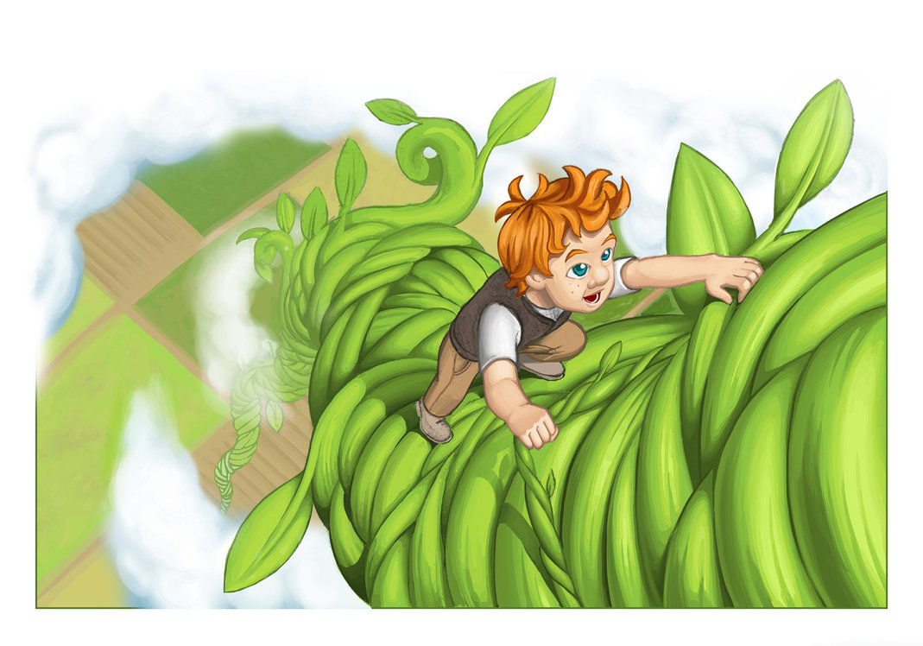

***Dates for your Dairy***

14 – 25 May – eggs/chicks in

25 May – last day of term 5

***Personal, Social and Emotional Development***

The children will have a new sensory area in the garden to explore and look after. It is planned that this is an area where children can reflect and be calm.

There will be circle time discussions on how to resolve difficulties and conflict with each other. For some moving on to school we want to ensure they are confident and able to express their feelings and needs. Children will be taking on responsibility for looking after our plants and chicks.

***Knowledge and Understanding of the World***

The children will gain an understanding of growth and change as we learn about plant growth and the lifecycles of frogs and chickens. They will have an opportunity to observe chicks hatching out of eggs. Living Eggs will give us ten eggs ready to hatch and all the equipment to look after them. The children will be learning to care for living things as they help to look after the chicks and tend the growing plants in the garden.

The children will learn about St George’s Day and we will discuss the Royal Wedding.

***Following the Children’s Interests –***

The children are really enjoying the focus on story telling so this term we are encouraging them to make up their own stories known as ***‘helicopter stories’.*** Staff will record exactly what the children say. The story will be typed up and put in a book of stories. Each story will be narrated by staff and the author for other children to act out.

***Communication, Language and Literacy***

Our focus on children making up their own ‘helicopter stories’ will give the children opportunities to develop their vocabulary and express their ideas using more complex sentences to link their thoughts.

As children act out the helicopter story all children need to maintain attention and concentrate listening so they know what to do.

Children will be encouraged to ask questions. What do they want to find out about the chicks?

***Literacy***

Daily phonic sessions will be focusing on hearing initial and some children will work on medial and final sounds so they can blend and segment CVC words.

The children will be looking at information books about frogs, chicks etc. We will discuss how these differ from story books and record the information we find out. Children will also use computers to find out information.

***Mathematical Development***

There will be a number focus this term ensuring the children have a good understanding of the numbers to ten. Children will be matching numbers and quantities. They will be comparing amounts with a focus on the vocabulary ‘more’, ‘less’, how many more do I need to make 5 etc.

Children will begin to explore time by sequencing the things they do in the day and discussing morning/afternoon/night.