***Dates for your Dairy***

6 June – PTA special event

(afternoon session only)

2 July – Move Up Day

18 July – Beach Party Day

19 July – Last nursery day.

***Links with Parents***

TBC – a series of school readiness workshops and meeting.

TBC – Sports Day

***Mathematical Development***

This term there will be a focus on measures. Children will explore weight, capacity and length. They will be encouraged to use the correct vocabulary eg. heavier/lightest longest/shorter than/ full/ empty.

In numeracy the children will be creating tally charts to find out information such as favourite ice cream flavour, fish etc.

As they explore numbers and amounts there will be a focus on ‘one more than’ makes....

***Literacy***

Daily phonic sessions will continue to focus on hearing initial and some children will work on medial and final sounds so they can blend and segment CVC words. Using phonic IT games the children will be deciding if a word is a real one or a made up one.

Books such as ‘A fish who could Wish’ will enable us to focus on rhyming words with an aim to generate rhyming strings eg fish/wish/swish/dish.

***Physical Development***

There will be a focus on using small equipment such as bats and balls, skittles etc. which will develop the children’s hand-eye coordination and improve aiming skills.

As they make a clay fish magnet they will be using tools to manipulate this malleable material.

Children will work on writing their name with correct letter formation. This includes activities to ensure children do circles in an anti-clockwise direction such as writing in sand and rice.

***Expressive Arts and Design***

Children will explore mixing media as they create under the sea pictures and paint sea creatures. Eg string painting, bubble painting, collages.

Children will be encouraged to manipulate the different materials to produce their own unique piece of artwork.

An under-sea cave and ice cream kiosk will be created to support role play. Lots of different playdough ice cream flavours will be made. The children will be playing alongside each other and co-operating with each other to develop a story.

**Rainbows Explorers Nursery**

Term 6 2018:

**Under the Sea**

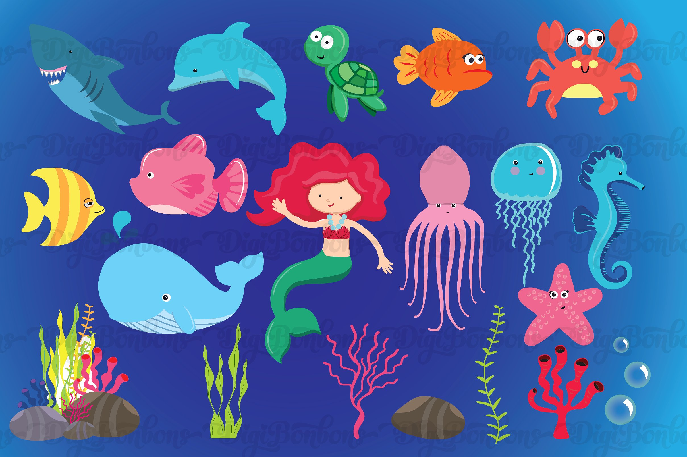

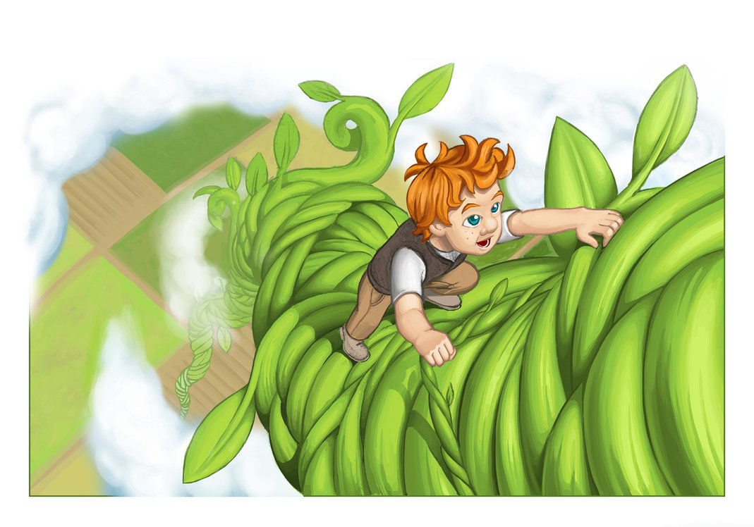

***Personal, Social and Emotional Development***

For those children moving to ‘big school’ the focus will be on preparing them for this period of transition. Visits will be made to our Reception classes. Using ‘Jigsaw’ with Jennie Jigsaw the children will participate in circle time activities to help them prepare for their move. For those children staying in nursery we will discuss making new friends.

Children will be reflecting on their abilities and what they have learned and enjoyed in nursery.

***Knowledge and Understanding of the World***

We will discuss the Muslim celebration of Eid, the end of Ramadan, during the week of 11 June. The children will learn about some Muslim artefacts and traditions. Father’s day cards will be made with discussions on what they or granddad/uncles do for them.

Technological skills will be developed as the children use bee-bots. They will learn to programme them to go in different directions.

Investigation skills will be developed as the children make their own lollipops and observe changes to ice in different temperatures.

***Following the Children’s Interests –***

The children have begun talking about their holidays and ice cream. Therefore, we have chosen this theme beginning with exploring under the sea before moving onto the beach. Our end of year celebration will be a beach day party.

The children love making up their helicopter stories so we will continue to listen to and act out these stories.

***Communication, Language and Literacy***

The children will be developing their vocabulary as they find out about the different creatures living under the sea. They will be encouraged to use describing words as they create under the sea poems.

Children will be following directions in events such as sports day, cooking activities etc.

There will be lots of opportunities for the children to speak and listen to each other. They have lots of ideas and thoughts to share at this time of year.