Reception Home Learning Summer 1 ‘18 – ‘How to Lose a Lemur’ (and other animals) by Frann Preston-Gannon
Make an information sheet or even an information book about your favourite animal.  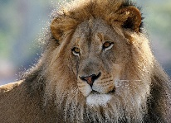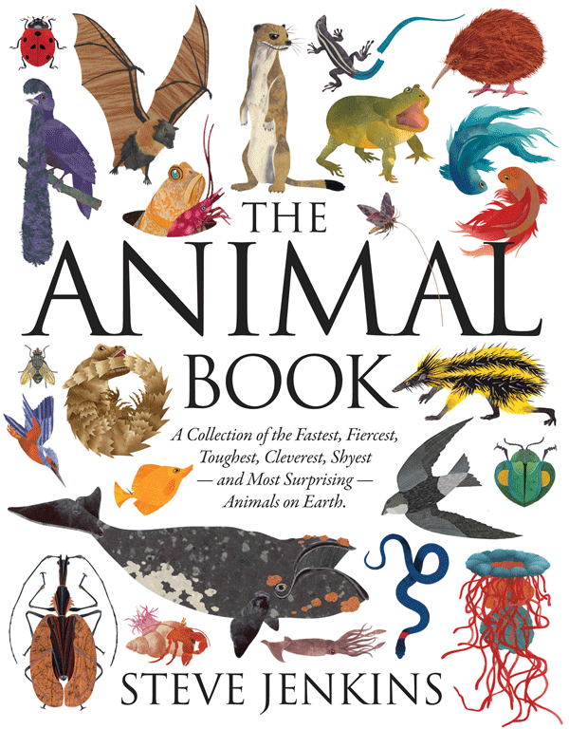 | Make a meal for a lemur or another animal. Find out which foods they like to help you.  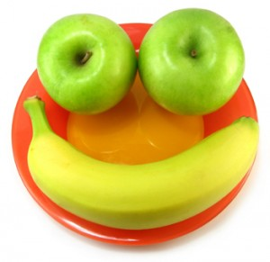 | Go for a walk in a forest or woods, which British wildlife can you spot? Did you spot any signs of wildlife like footprints or animal homes?  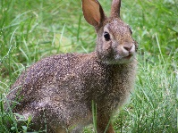
Make a model of an animal. You could make a real animal or invent a new animal. Use junk modelling, plasticine, clay or any other materials you have at home.  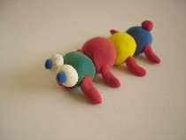 | If you have a pet at home, put some photos of your pet on Tapestry and share them with your friends at school.  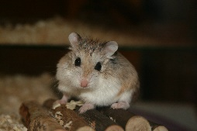 | Visit the library and find some story and information books about animals-you could bring your favourites into school to share with your class.
Decorate a rock (Didcot Rock) with a painting of your favourite animal, animal story character or an animal you have made up. Hide the rock near school or somewhere in Didcot for other children to find.  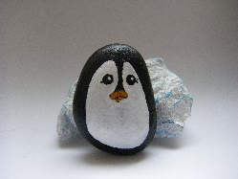 | Make a shoebox habitat showing all the animals which might live in a type of habitat (e.g. a desert, a wood, the sea). You could write labels for the animals in your habitat or even add an interesting fact about each animal.  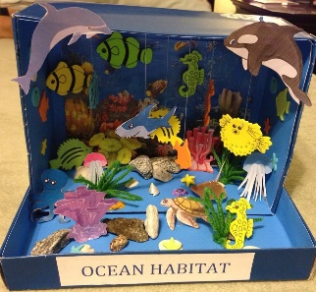 | Design a new animal or insect. Draw a picture of your new creature, decide on a name for it and label the different parts. You could decide where your creature will live and draw it in its habitat. It could even be a mix up of other animals you already know about.  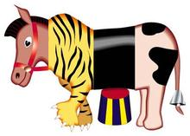
Be as creative as you like and enjoy the home learning activities. We would LOVE to see more photographs and notes on Tapestry about any home learning – either using the ideas on this page or any other ‘wow’ moment!

