Rainbows Explorer’s Home Learning Summer 1 Theme: Imagination

**M**ontanheiro **R**owan **C**ummings **S**peckels

**m**ummy **r**oad **c**at **s**un

**m**ud **r**iver **c**up **s**and

**m**an **r**un crumpet **s**ausages

Use your imagination, can you tell your teddy a story that you have created all by youself?



Have a look at your baby photos, how have you changed? What can you do now that you are 3 or 4?

 

Can you write some rules about staying safe when you cross the road?

 

What sound does your name start with? Can you think of any other words that start with the same sound?

Montanheiro

Practice your ball skills. How many times can you throw and catch or kick the ball?



What can you find out about frogs or chicks on a computer or I pad? Create a picture of one to bring into nursery.

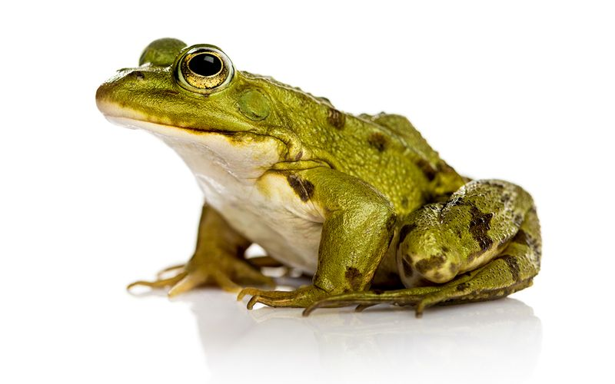

What numbers can you spot on a car registration plate? Can you find your age on the registration plate?

 

**If you do any home learning please put it on tapestry, we would love to see it**

Have a look in a book, can you find any letters that are in your name?



Can you help your family set the table, how do you carry the crockery and cutlery?

