Rainbows Explorer’s Home Learning Summer 2 Theme: Under the sea

Look at some of your holiday photos. Which was your favourite holiday? Plan something to do in the summer holiday. 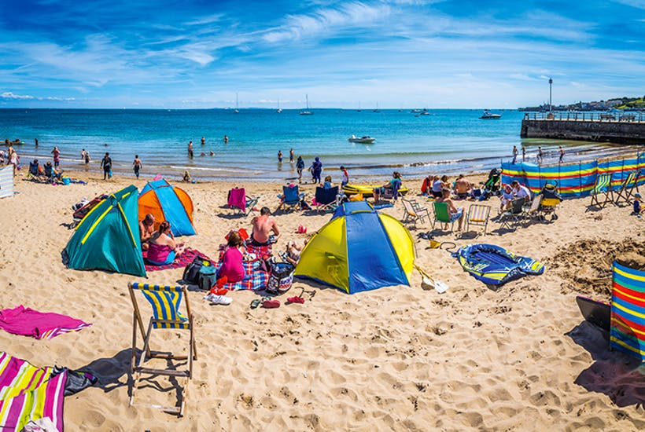

Ask members of your family what is their favourite ice cream flavour. How can you record that information?



Have you got a remote control toy you can make move? Can you use a camera to take a picture of it? Mums and dads please put this on tapestry for us.

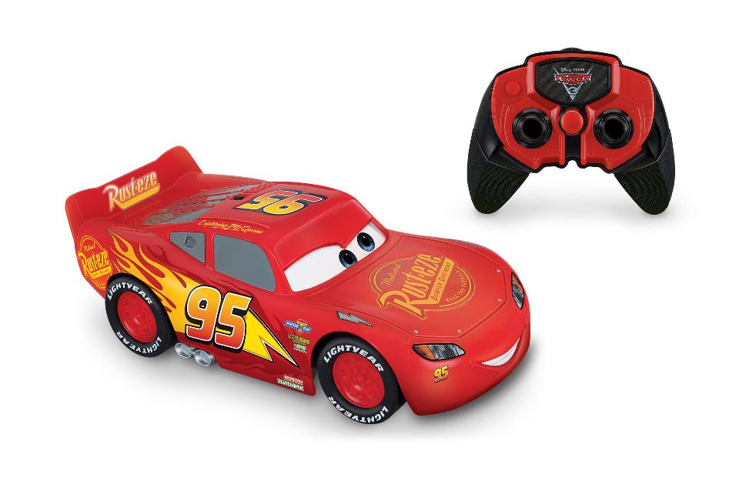

Use a bat and ball/shuttlecock etc. Can you hit it to another person?

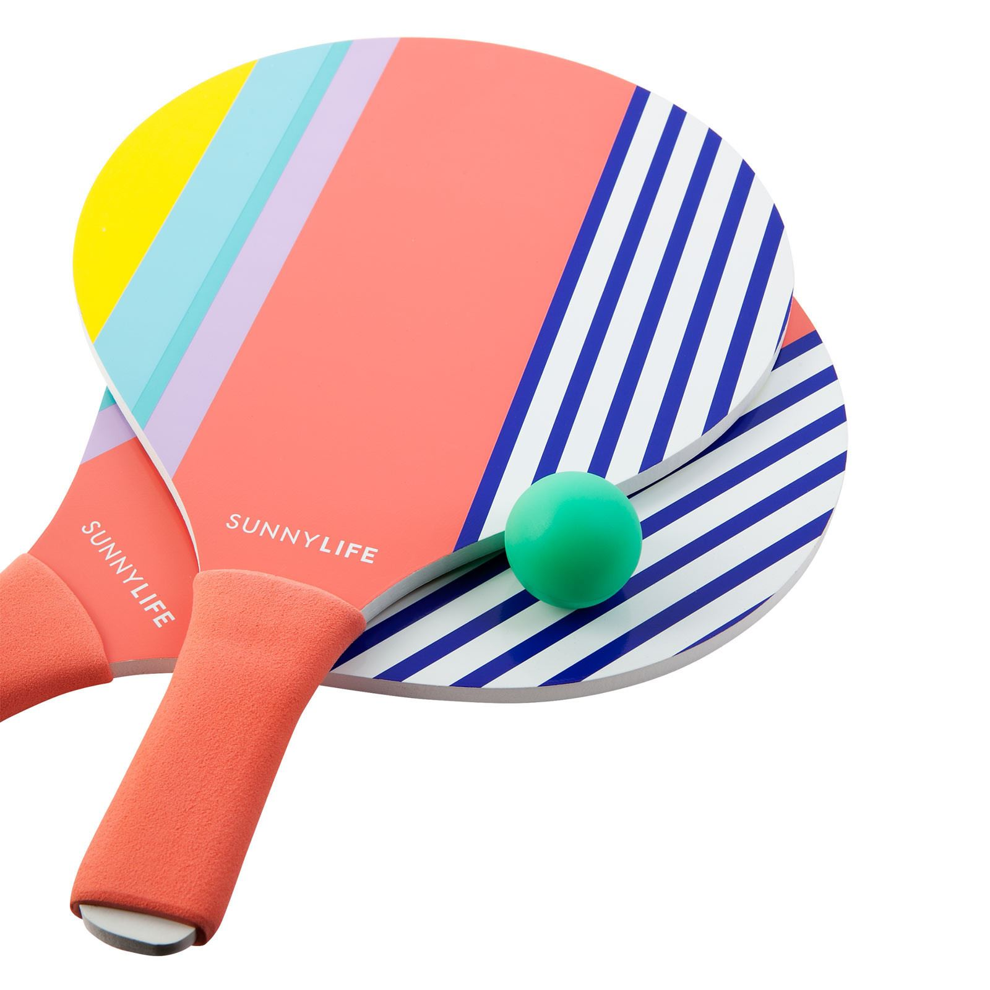

How many words can you think of that rhyme with cat? Fish? Mop? Pin

Are they real or made up words?

Mip sip tip gip

Draw a picture of your favourite thing you do in nursery.

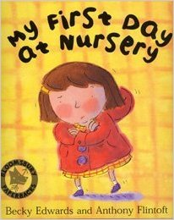

What can you find out about a creature that lives under the sea?

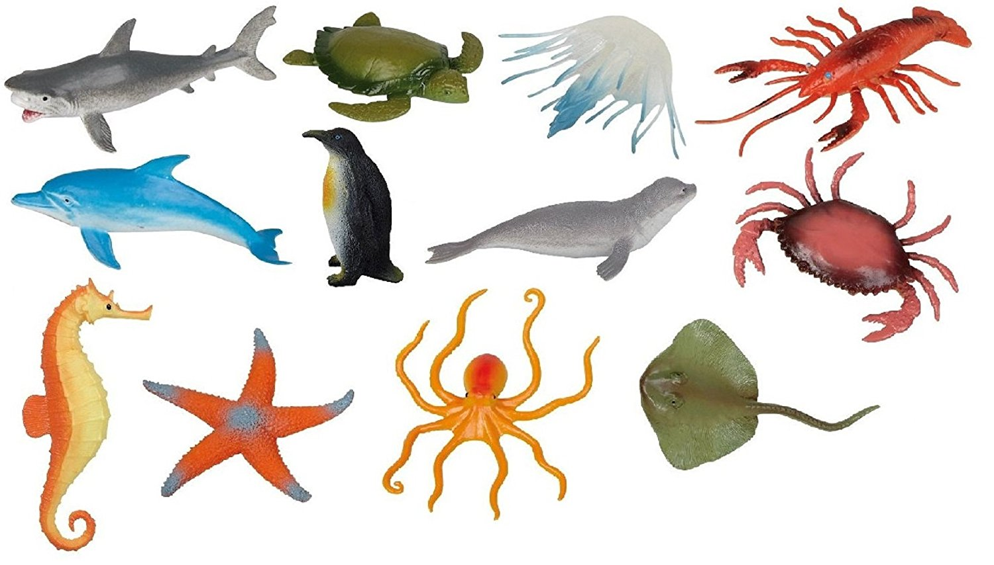

**If you do any home learning please put it on tapestry, we would love to see it**

Read your Bookstart Book – ‘Don’t call me sweet’. Can you create a monster picture or model? Is it a sweet or scary one?

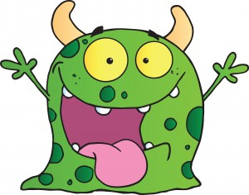

Use your hand or foot to measure some things in your home. Which is the longest? Which is the shortest?

