Make a scrapbook about your pet. What is its name? How old is it? What does it like to eat? | 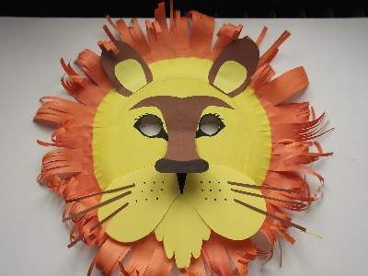  Make an animal mask or hat. | 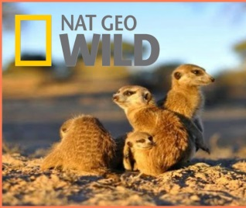  Watch documentary footage of animals in the wild. Try making your own documentary video about your pet or a wild animal.
Design a new animal and explain its features. | An idea of your own! | Choose an endangered animal to draw or paint. Find out where it lives and why it is endangered.
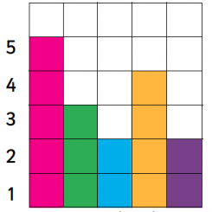  Find out about your family and friends pets. Record the results as a block graph or a pictograph and highlight which pet is most popular. | 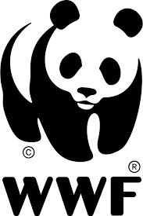  Find out about different animal charities. What can you do to help? | 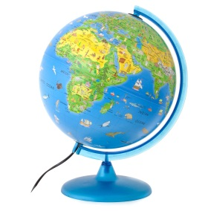  Locate on a world map or a globe where all your favourite animals come from in the world.

